 | CHAROTAR UNIVERSITY OF SCIENCE & TECHNOLOGY  DEVANG PATEL INSTITUTE OF ADVANCE TECHNOLOGY AND RESEARCH | 

Weekly Report-3

Student ID:23DCS134 | Student Name:Venisha Thakker
From Date:12/05/2025 | To Date:16/05/2025
Semester:4th | Internship ID:

Work done in last week (Attach supporting Documents):

- Integrated Leaflet.js for pickup & drop-off map selection
- Developed Booking Form with city, pickup, drop, and cab type
- Add fare calculation logic(based on distance and cab types)
- Auto-assigned random available driver for each new booking
- Implemented status update functionality (Approve, Reject, Complete) for Driver.
- Saved booking data in MongoDB.
- Connected all frontend forms and pages with respective backend APIs using Axios.

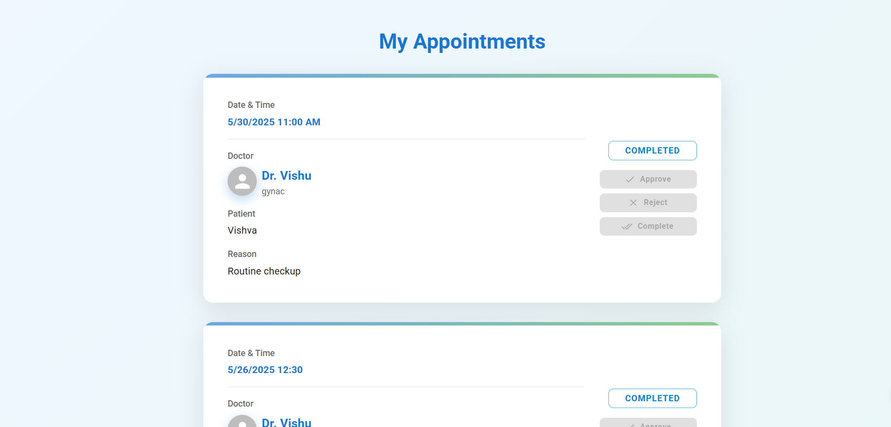

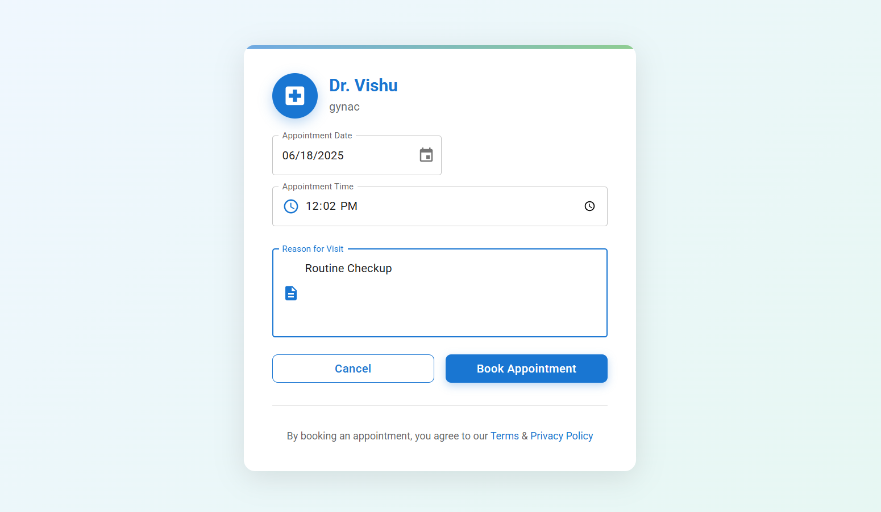

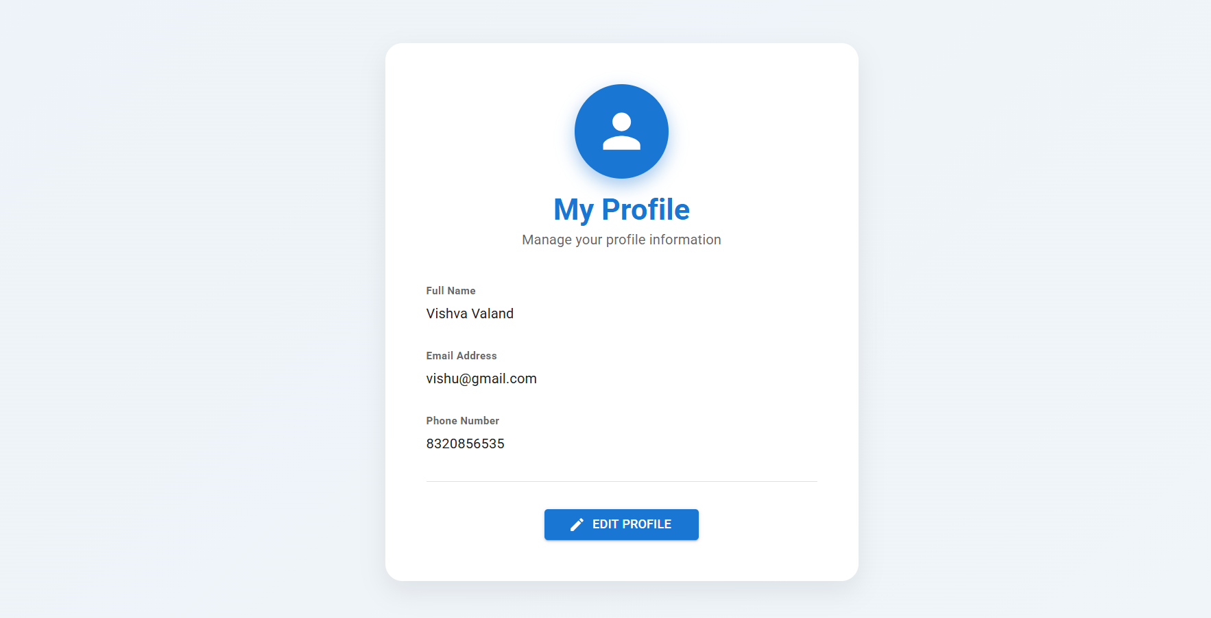
Plans for next week:

- Build UI for "My Bookings" and "Active Ride" views
- Show driver details post-booking
- Start admin analytics page (total bookings, users, drivers etc)

References:

- Leaflet Docs: https://leafletjs.com
- Axios HTTP Requests: https://axios-http.com

Signature of External Guide Signature of Internal Guide

